Assignment 4
Consider the following table: Table: CLASS
ID Name
1 Bravo
2 Alex
4 Cheng
Give the output of the following SQL script:
1-INSERT INTO class VALUES (5,’Rahul’);
2-COMMIT;
3-UPDATE class SET name = ‘Abhijeet’ WHERE id= ‘5’;
4-SAVEPOINT A;
5-INSERT INTO class VALUES (6, ‘Chris’);
6-SAVEPOINT B;
7-INSERT INTO class VALUES (7, ‘Bravo’);
8-SAVEPOINT C
9-SELECT * FROM class;
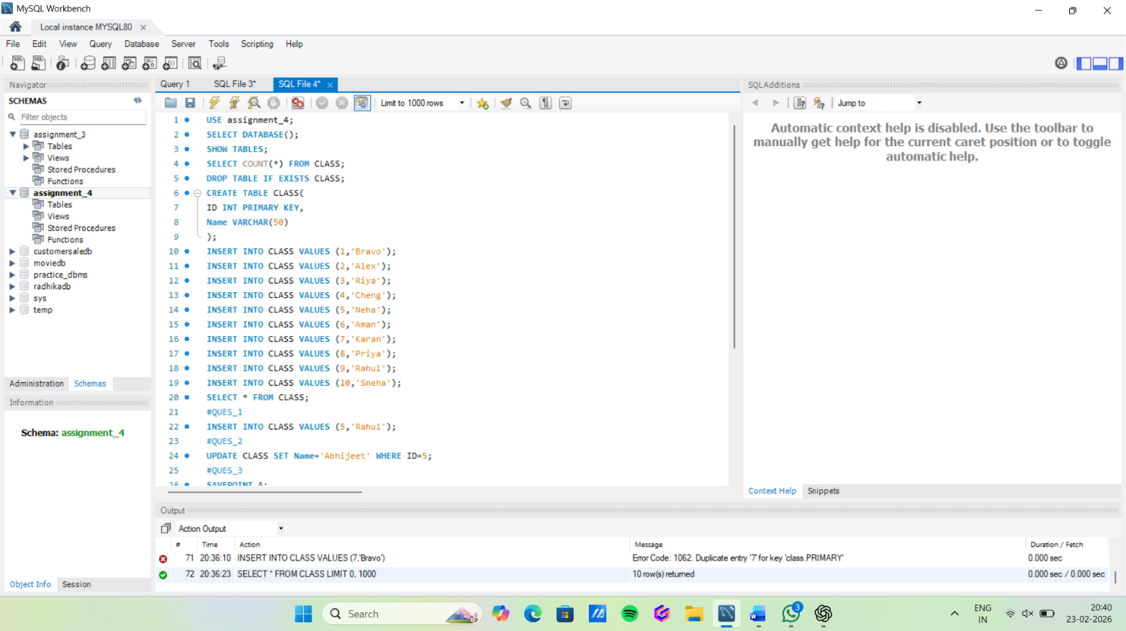
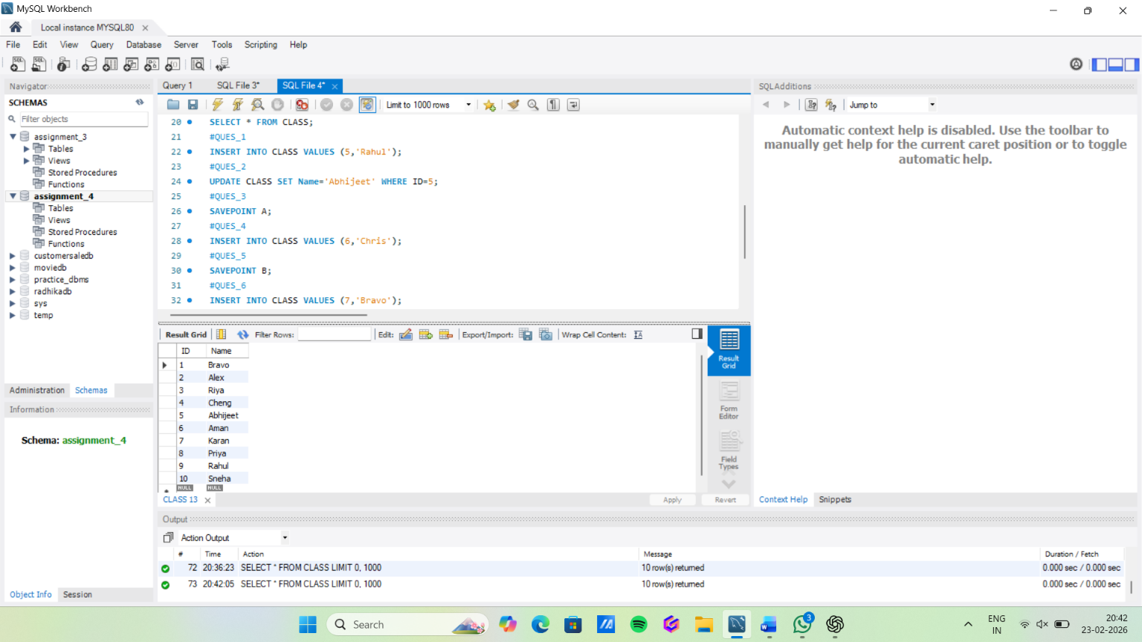

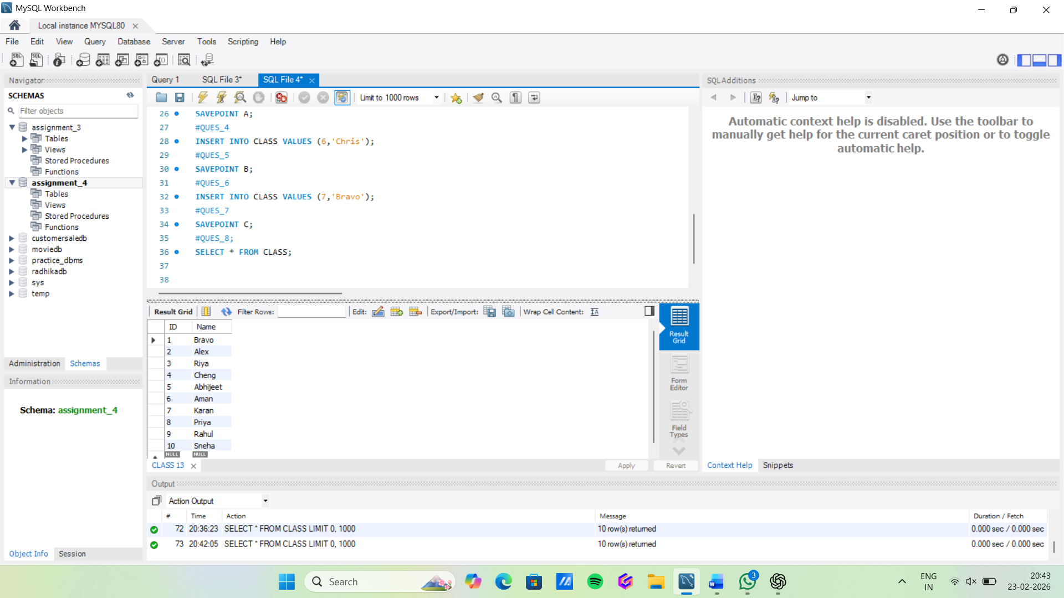
10-ROLLBACK TO B;
11-SELECT * FROM class;
12-ROLLBACK TO A;
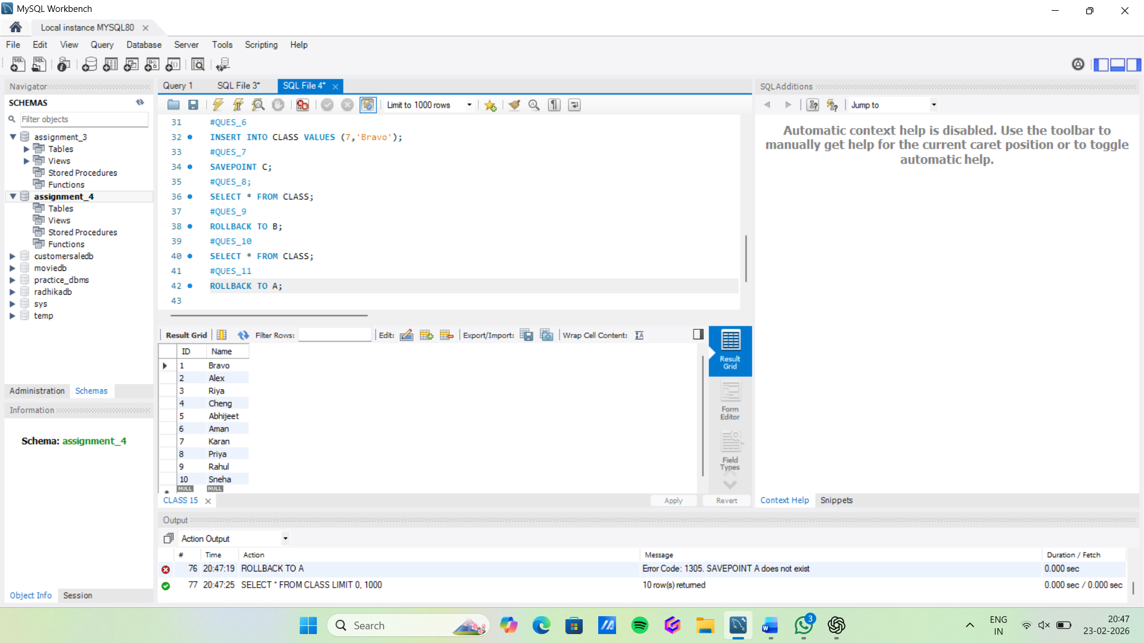

ASSIGNMENT 4.2

Consider the following table: Table: ACCOUNT_TXN

Perform the following TCL-based SQL script and write the output after each SELECT statement:
1-INSERT INTO ACCOUNT_TXN VALUES (104, 'Diya', 4000).
2-SAVEPOINT S1.
3-UPDATE ACCOUNT_TXN SET Balance = Balance - 1000 WHERE Acc_ID = 102;
4--UPDATE ACCOUNT_TXN SET Balance = Balance - 1000 WHERE Acc_ID = 102.
5-SAVEPOINT S2.

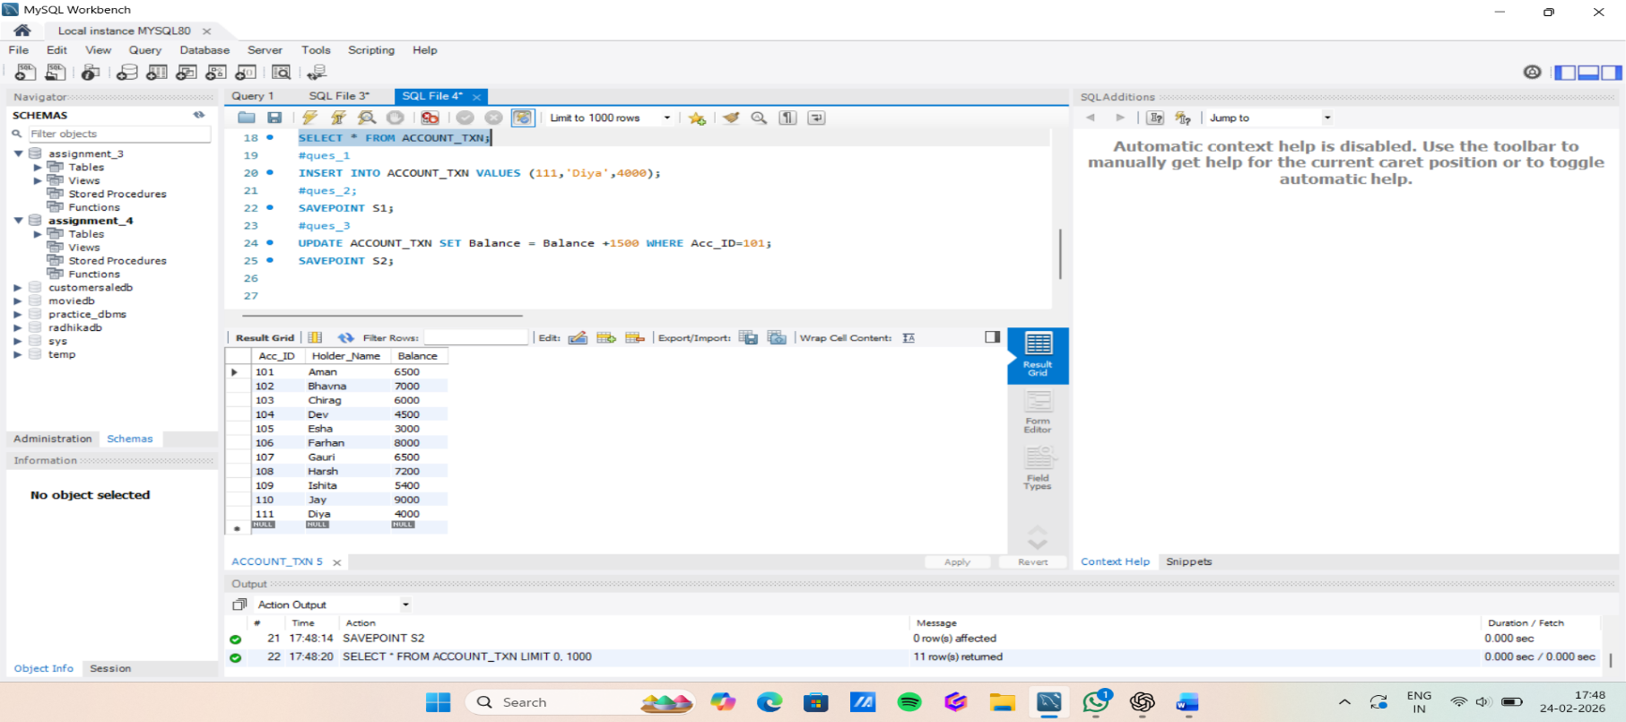
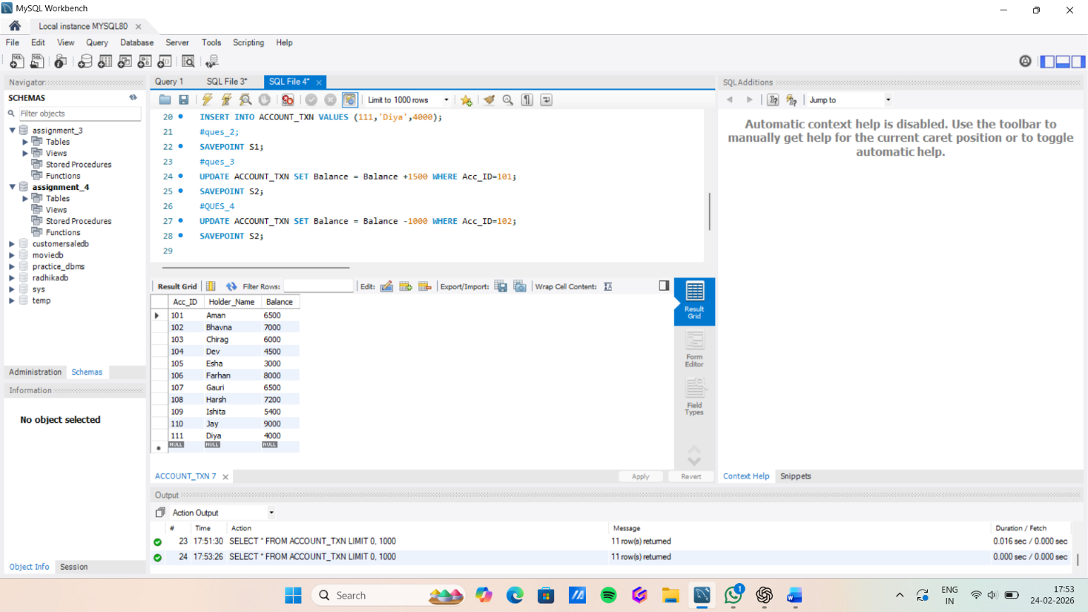

6-DELETE FROM ACCOUNT_TXN WHERE Acc_ID = 103.
7-INSERT INTO ACCOUNT_TXN VALUES (105, 'Eshan', 3000).
8-SAVEPOINT S3.
9-UPDATE ACCOUNT_TXN SET Holder_Name = 'Bhavna Sharma' WHERE Acc_ID = 102.
10-SELECT * FROM ACCOUNT_TXN.
